**NET-SNMP Package**

**(1) Source Code:**

<http://www.net-snmp.org/download.html>

**(2) Compiling on Ubuntu/MP1:**

**$ sudo apt-get install libperl-dev**

**$ sudo chmod -R 777 \***

**$ sudo chown cyber:cyber -R \***

**$ ./configure --host=arm-linux --target=arm-linux --with-default-snmp-version="3"**

**$ make**

**$ sudo make install**

<http://www.net-snmp.org/wiki/index.php/Net-Snmp_on_Ubuntu>

**(3) EXECUTION FILE PATH:**

**/usr/local/sbin/snmpd // snmp server**

**/usr/local/sbin/snmptrapd // snmp trap server**

**/etc/snmp/snmpd.conf // snnp server configure file**

**/etc/snmp/snmptrapd.conf // snmp trap server configure file**

**/var/log/snmpd.log // snmp server log file**

**(4) How to Check Server Status**

**$ sudo lsof -i -P –n**

**(5) custom sysetmd service**

**/etc/snmp/snmpd.conf**

**/etc/systemd/system/snmpd.service**

**(6) systemd service setup/manage**

**$ sudo systemctl daemon-reload # 重新載入設定檔**

**$ systemctl restart snmpd.service # 重啟服務**

**$ systemctl status snmpd.service # 確認服務狀態**

**$ systemctl stop snmpd.service # 停止服務**

<https://blog.gtwang.org/linux/linux-create-systemd-service-unit-for-python-echo-server-tutorial-examples/>

**(X) FIX BUG:**

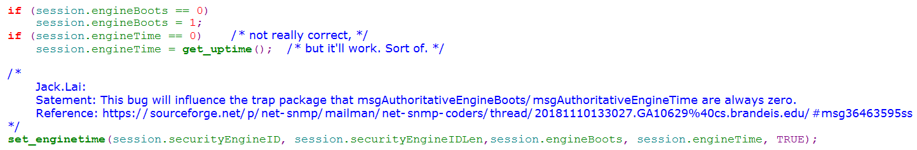

[**snmptrap not populating EngineBoots or EngineTime for snmp v3 traps**](https://sourceforge.net/p/net-snmp/mailman/message/36463595/)

<https://sourceforge.net/p/net-snmp/mailman/net-snmp-coders/thread/20181110133027.GA10629%40cs.brandeis.edu/#msg36463595>